Zen Internet

Zen IaaS Cloud Welcome Pack

Issue: 2.3

Date: Wednesday, 23 March 2016

Contents

1 Accessing your Zen Cloud service 3

2 Using the Service 4

2.1 Creating a Network 4

2.2 Creating a new vApp 6

3 Frequently Asked Questions 10

3.1 Where do I go to configure my Edge Gateway? 10

3.2 How do I see the external IPs of my Edge Gateway? 10

3.3 How do I configure the Edge Gateway NAT so that my VMs can communicate out to the Internet? 10

3.4 Why can't I upload media to vCloud via my web browser? 10

3.5 How do I access backup for vCloud? 11

4 Support 12

4.1 Contact Details: 12

4.2 Technical Support 12

4.3 Incident Management 13

4.4 Problem Management 13

5 Service Level Agreement (SLA) 14

5.1 SLA Overview 14

5.1.1 99.99% availability 14

5.1.2 One hour response 14

5.2 Compensation & Limits 14

5.3 Exclusions 15

5.4 Definitions 15

1Response 15

2Scheduled Maintenance 15

3Emergency Maintenance 15

6 Version History 16

# Accessing your Zen Cloud service

Thank you for choosing Zen Internet as your Cloud service provider. You can log-in to your Cloud service using the following credentials: **\*\*\*Please keep these details safe\*\*\***

|  |
| --- |
| **Profile Technology Services Ltd for Royal Cosmetics** |

_______________________________________________________________

User URL: <https://vcloud.zen.co.uk/cloud/org/Royal-Cosmetics-IAAS>

Username: Roy-Admin

Password: p0LXUa8F

_______________________________________________________________

**Initial IP Addressing**

|  |  |
| --- | --- |
| Public IP 82.71.253.78 |  |
|  |  |

The screenshots in this document use fictional company ‘ABC Widgets.’ The view from your web browser will be similar.

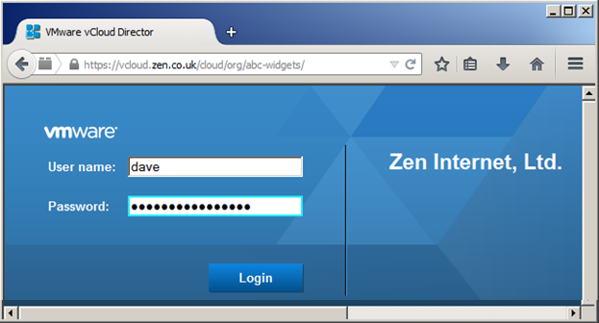

Should you require any assistance then please contact Zen support or refer to the FAQ.

# Using the Service

Before you can use Zen Cloud fully, there are a number of stages which need to be completed. This guide will walk you through each of these steps. Please note, some of the sections may already have been completed for you as part of the deployment.

## Creating a Network

Open the Administration Menu

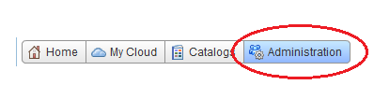

Open Your VDC (Virtual Data Centre)

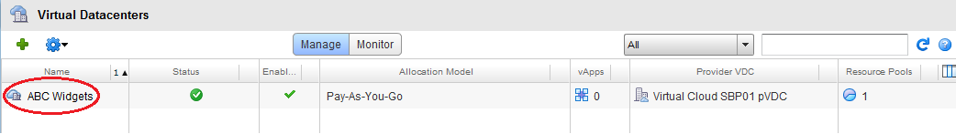

Select Org VDC Networks

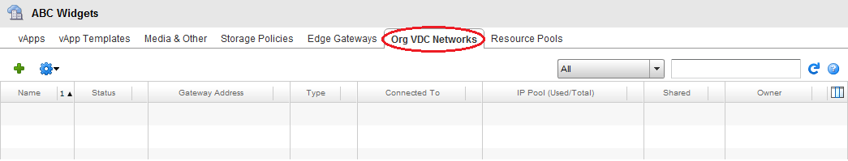

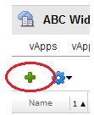

Select the Plus to add a network

Select Create a Routed Network, and Select your Edge Gateway.

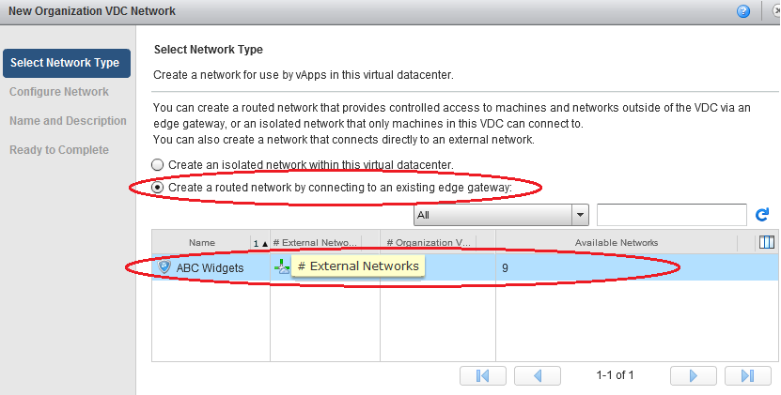

Fill in the network details to define the Required IP Range

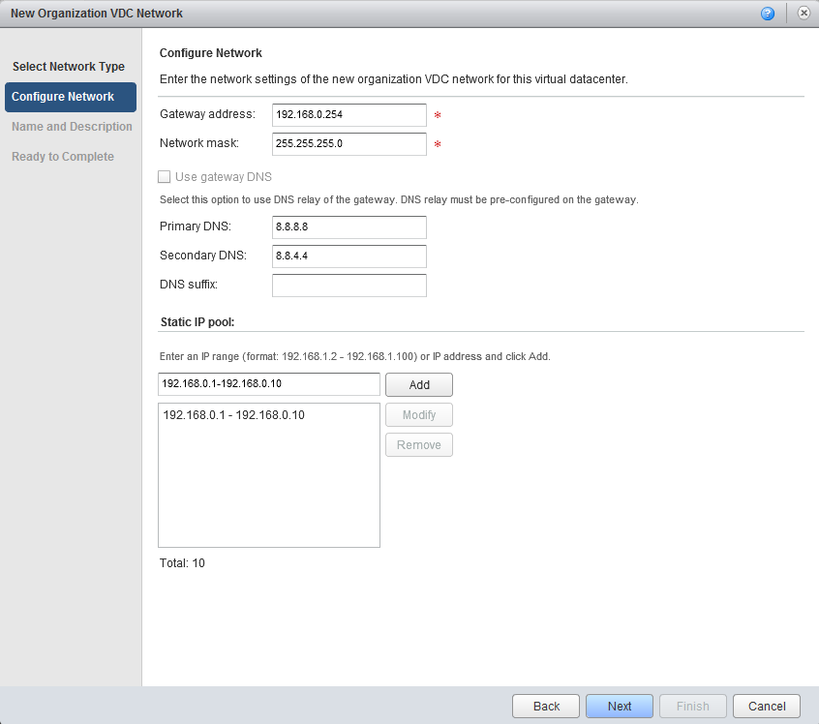

Name your Network and click Finish.

## Creating a new vApp

Begin by selecting ‘Add vApp from Catalog’ from the ‘Home’ tab

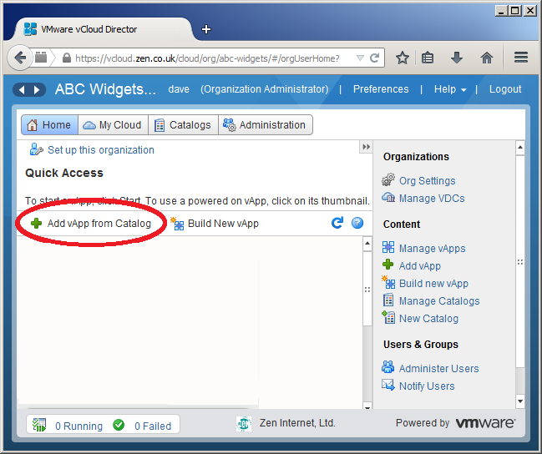

Select the operating system you want by following these steps:

1. Select ‘Look in: Public catalogs’ to see the OS images published and updated by Zen
2. Select ‘All Templates’ to ensure the full range of images
3. Enter a search term and press Return to display only the images you want e.g. ‘2012’ for Windows Server 2012 and 2012 R2
4. Click ‘Created On’ to sort the list showing the newest images first.

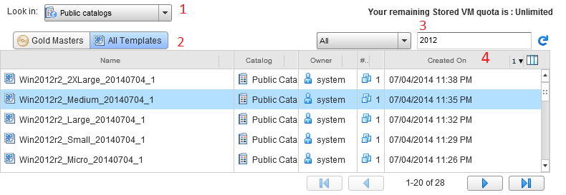

Give the vApp a useful name – this name will appear in the vCloud dashboard and also in any detailed invoices generated based on your usage. This can help to apportion costs to the correct cost centre within your business.

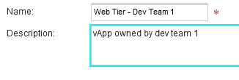

Each vApp comes preconfigured with a single VM. More can be added later, and for now give the VM a name as it will be displayed in the vCloud dashboard and on detailed invoices:

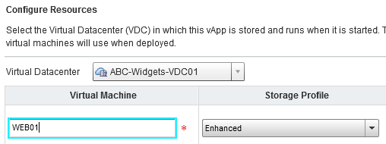

The final steps are to assign the hostname that the new VM will be assigned, and decide on which network to link the VM’s network interface card to:

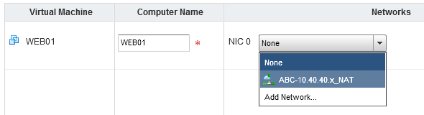

Now the vApp has been created, click the green ‘Play’ icon to launch it:

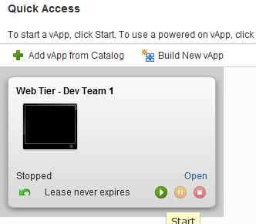

Click on the console to launch the VGA console viewer. Use the ‘keyboard’ icon in the top right hand corner to send a ‘Ctrl-Alt-Del’ sequence.

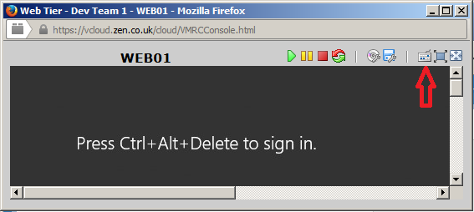

Each Windows VM has a randomly generated Administrator password. You can find this password by clicking ‘Open’ on the ‘Web Tier – Dev Team 1’ vApp portion of the Home tab.

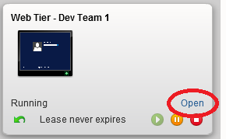

Locate the VM in the network diagram and right click on it to access the ‘Properties’ option. Now browse across to ‘Guest OS Customization’ and the ‘Password Reset’ section of that tab will show the Administrator password:

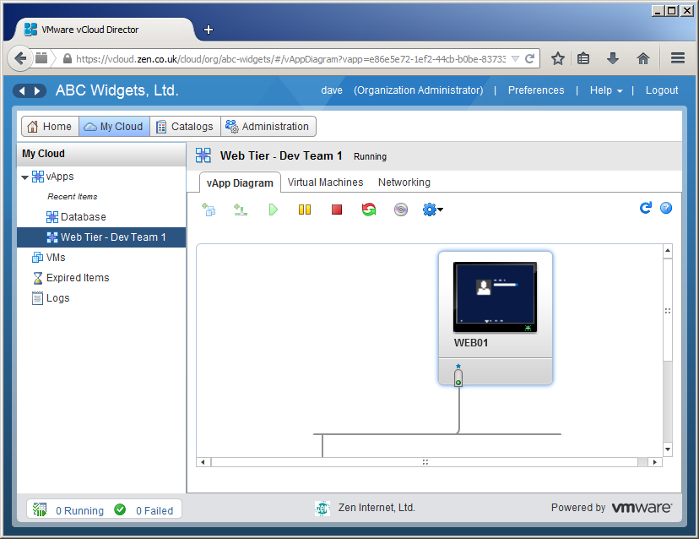

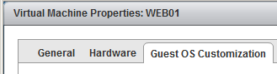

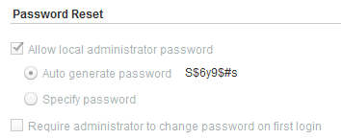

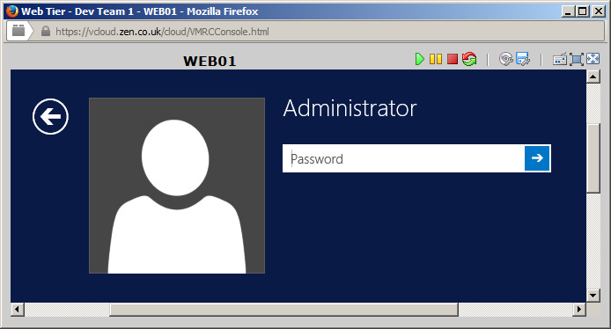

# Frequently Asked Questions

## Where do I go to configure my Edge Gateway?

From the main page; to get to Edge Gateway Configuration:

* select the "Administration" tab and double-click on your VDC
* select the "Edge Gateways" tab (on the next tier of tabs)
* right-click on your edge gateway and select ‘Edge Gateway Services’

## How do I see the external IPs of my Edge Gateway?

As above, but in the final step select ‘External IP Allocations’

* Right click the desired Edge Gateway -> Select "External IP allocations"

## How do I configure the Edge Gateway NAT so that my VMs can communicate out to the Internet?

From the edge gateways section; to get to NAT configuration:

* In ‘Edge Gateway Services’ select the NAT tab

Setup outbound NAT:

* Click "add SNAT..." -> Set "Applied On" to your external network ->Set "(internal)" to your internal subnet or VM IP -> Set "External" to a "Sub-Allocated IP" on your external network.
* As an example, this rule allows any VM in 10.40.40.0/24 to access the Internet using IP address 88.98.53.97



## How do I access backup for vCloud?

**VM Back-up**

For your convenience and protection, we will automatically back-up all the VMs that exists within your Cloud environment. These back-ups will be conducted daily, with data retained for 14 days.  
***Please be aware this will only provide a restore of the full server by default. For details of File level backups and restores, please contact our support teams for details.

**Contacting our support team:**

* E: [managed.hosting@zen.co.uk](mailto:managed.hosting@zen.co.uk)
* T: 01706 902190 opt 4
* Opening hours for backup job requests, plan changes and VM test restores are:
  + Monday  to Friday, 9am to 5pm (excluding Bank Holidays)
* Emergency restores for the recovery of production VMs can be requested 24x7x365

# Support

## Contact Details:

To access Zen Support please use the following contact methods:

* Telephone: 01706 902190 opt 4
* Email: [managed.hosting@zen.co.uk](mailto:managed.hosting@zen.co.uk)

## Technical Support

Technical support covers all non-service affecting issues. This includes guidance on how to configure services within the Zen Cloud and how to create back-up schedules for VMs. We will provide a library of knowledge base articles to assist with general support and configuration queries. In the event that you cannot resolve an issue using the provided knowledge base articles then you can contact our UK based technical support team as follows:

* Business hours telephone technical support (Mon-Fri, 9am-5pm, excluding Bank Holidays)
* Email ticket box (manned Mon-Fri, 9am-5pm, excluding Bank Holidays)

We shall use our reasonable endeavours to ensure that any request for support will receive a response within 4 business hours of a ticket being raised by us.

## Incident Management

Incident Management covers all issues affecting the availability of your service.  Whilst we monitor your service and proactively manage any service affecting faults, there may be times that faults are brought to our attention by our customers.

We will provide a 24/7/365 service desk (accessible by telephone) for you to raise any suspected service affecting incidents.

Upon contacting us by phone a Zen engineer will respond to you within 60 minutes and, within the agreed service hours, we will:

* Log, record and confirm acceptance of the incident request
* Determine the urgency, impact and priority of the incident
* Investigate, diagnose and check against a knowledge base of known errors
* Recover the service to normal operation or put in place a suitable workaround,  at which point the Incident is closed
* Escalate to Problem Management if an underlying cause of the Incident is suspected.

## Problem Management

Problem Management will investigate the root cause of the incident and declare a Known Error when the root cause is known and a workaround or fix is available. Known errors will be notified to any third party or the Zen work team responsible for that part of the solution to create a permanent fix. Our Third Party Management service will track the performance of any suppliers/the third parties.

# Service Level Agreement (SLA)

## SLA Overview

### 99.99% availability

Subject to the exclusions detailed below, access to the portal through which you manage your Zen Cloud – *and the resources therein* - will be available for a minimum of 99.99% of time during a calendar month

### One hour response

Subject to the exclusions detailed below, we will ensure that any fault related support query receives a response1 from a Zen engineer within one hour of the query being raised to us.

## Compensation & Limits

* The remainder of this clause is subject to clause 6 of the Core Terms.
* We will pay the equivalent of one day's Monthly Service Charge for each hour that that we breach the above availability and response time metrics.
* All service charge credits will be raised in respect of the charges for the affected product or service in the next charging period that follows the period of 30 days following the failure in question. Credits raised will be deducted from your next invoice.
* Service credits or other claims for financial compensation in respect of any given calendar month in which a failure or fault occurs shall not in any circumstances exceed the total monthly service charge (i.e. the actual monthly charge or a pro-rated monthly charge where the actual billing period is longer than a month) for the Services for such given month, regardless of the number of faults reported and/or occurring in that period against any other product or service supplied by us.
* Customers can only make one claim under the Service Level Agreement in respect of a single fault ticket and accordingly service credits will not exceed the amount of one day's service charge for each hour of failure (notwithstanding that such failure is a concurrent failure of two or more of the said Service Levels) arising out of one fault.

## Exclusions

* The SLA will not apply and claims for service credits or other financial compensation cannot be made in respect of the following:
  + outages and/or loss or failure of service resulting from Scheduled Maintenance2 or Emergency Maintenance3;
  + faults which are the result of misuse or interference by you or any third party with the Service or any equipment supplied and managed by us;
  + any service unavailability due to faults with local Internet connectivity;
  + any outage and/or loss or failure of Service caused by your software or changes that you have made to the Service; and/or
  + any outage and/or loss or failure of service resulting from Force Majeure.

## Definitions

### 1Response

Zen Internet will provide a formal response within one hour of the fault being raised by the customer. The response will include formal acceptance that there is a fault and a high level schedule for remedying the fault. An on-going communication plan will also be agreed with the customer at this time so that we can keep them informed whilst we continue to investigate and/or fix the fault. For clarity, the response time is not the time in which we guarantee to fix the fault.

### 2Scheduled Maintenance

Scheduled maintenance covers a disruptive change or a non-disruptive change which results in loss (or potential loss) of resilience. In order to perform Scheduled Maintenance, a system downtime ("Maintenance Window") is reserved. The Maintenance Window operates from 11pm to 6am Monday to Sunday. When it is reasonably practical to do so, we will schedule any Service affecting Scheduled Maintenance activity to fall within a Maintenance Window, however, we shall not be obliged to do so. We will aim to give a minimum 72 hours’ notice (via our Service Alerts page - <http://status.zensupport.co.uk/>) prior to performing scheduled maintenance, however we shall not be obliged to do so.

### 3Emergency Maintenance

Emergency maintenance covers issues pertaining to service loss and/or operational faults and includes all works which must be carried out by us to preserve the safety, security or integrity of the Service. Emergency Maintenance will be scheduled on a case-by-case basis. It may not be practicable to provide any prior notice; however, we will use our reasonable endeavours to notify you via our Service Alerts page within 1 hour of the service being restored.

# Version History

|  |  |  |  |  |
| --- | --- | --- | --- | --- |
| **Issue** | **Change** | **Date** | **Author** | **Approver** |
| 1.0 |  | 21/07/2014 | Adam Clements |  |
| 1.1 | Additional user guide information | 21/07/2014 | Adam Clements |  |
| 1.2 | Updated | 17/06/2015 | Andrew Lord |  |
| 1.3 | Amended contact details for support | 06/07/2015 | Adam Clements |  |
| 2.0 | Updated Network Info | 03/09/2015 | Stuart Lowe |  |
| 2.1 | Minor layout & content changes | 20/02/2016 | Nick Furnell |  |
| 2.2 | Minor content change | 23/03/2016 | Managed Hosting | Operations Manager |